CBD FOR CBD
  - 8 Key “Competencies” for Faculty in Assessing Residents at McMaster

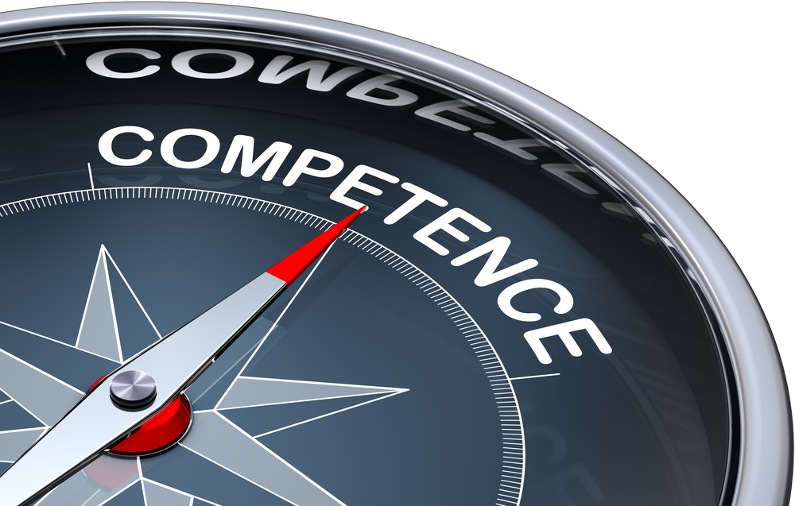

This template was prepared by the CBME Faculty Development committee with permission from
Drs. Karen Raymer & Alena Skrinskas who developed the
workshop guide for the Department of Anesthesia, McMaster University

October 2019

faculty Competencies

- Be familiar with the [Number of EPAs] in TTD Phase EPA’s for Transition to Discipline (TTD) and understand how they fit into day to day clinical teaching as well as the larger curriculum.
- Identify the two main types of assessment tools and to which type of resident they apply (CBD vs Traditional Program).
- Access the new electronic assessment tools in MedSIS .
- Know how to determine which tool should be used on a given day and who initiates the assessment process.
- Understand the different types of rating scales used within each tool.
    - assess the global EPA as well as the component milestones.
- Successfully submit the completed assessment form.
- Know what to do if the unexpected happens during the day- how to change the assessment plan.
- Be familiar with the “Narrative form”: When to use it and how to access it .

Faculty Competence #1
“Be familiar with the [Number of EPAs] in TTD Phase EPA’s for TTD and understand how they fit into day to day clinical teaching as well as the larger curriculum “
Under CBD, Residency is comprised of four phases. The first phase is “Transition to Discipline” (TTD) and lasts [length of your specialty’s TTD phase]. During TTD, Residents are expected to develop competence in the [Number of EPAs in TTD Phase] EPAs.

What are the EPA’s for TTD?
List your specialty’s EPA’s for TTD phase
TTD-1:
TTD-2:
TTD-3:
TTD-4:
…

How do the EPA’s fit into the day to day clinical teaching as well as the overall curriculum?
Clinical teaching and learning will extend beyond the TTD EPA’s, reflecting the clinical cases that the resident is exposed to as well as teaching style of their supervising faculty members. In addition to clinical exposure, CBD residents will have academic teaching sessions and simulation sessions, which will support the EPA’s but also extend outside the bounds of those EPA’s. EPA’s form one part of teaching and learning under CBD but should not be considered as a checklist that constrains learning and development to a short list of topics. Real learning is “messier” than a sequential list of EPA’s.

Faculty Competence #2
“Identify the two main types of ASSESSMENT tools and to which type of resident they apply (CBD vs Traditional MODEL or “TM” Program)”
- Faculty will continue to assess all residents each day, at the end of a one-on-one day together, same as our current model.
- [Modify statement as appropriate] All assessment tools will be electronic, accessed through MedSIS.
- [Modify statement as appropriate] Each day, only one assessment form is expected per staff.
 | CBD Residents  (PGY1 for start year) | TM Residents (for Residents Who Started Before Your Specialty’s Rollout Year)
Other Other Assessment Tools (ie. ITARs, Daily Encounter Cards, MSF, etc.) | [Modify as appropriate]  Yes! Other assessment tools will continue to be an important part of assessment, even in CBD | Yes!  Name of assessment tools used by TM residents in your program are the only type of tool for our TM residents
EPA assessments | Yes! The CBD residents will be required to demonstrate competence in the EPA’s, with several observations of each EPA over the phase | Briefly describe the type of assessment that will be used for TM residents. The TM group will get smaller each year.

Faculty Competence #3
“know how to Access the New Electronic ASSESSMENT tools in MEdSIS”
CBME MedSIS is available on your mobile device.
All forms in MedSIS can be accessed via your desktop / ipad / mobile; however, currently, only the CBME forms, can be triggered from your mobile device and only the CBME forms will you receive a link as soon as the form is triggered.
This differs from the ITARs and WBAs in MedSIS which are on a separate workflow i.e., links are sent out twice a week (however, if you login into MedSIS, you would be able to see the ITAR, WBA form there to complete, you just won’t receive a link until the send out days).
CBME Assessment Form Workflows
CBME forms can be triggered by both supervisors and trainees. Below are the workflows based on whether the supervisor or the trainee triggers the form.
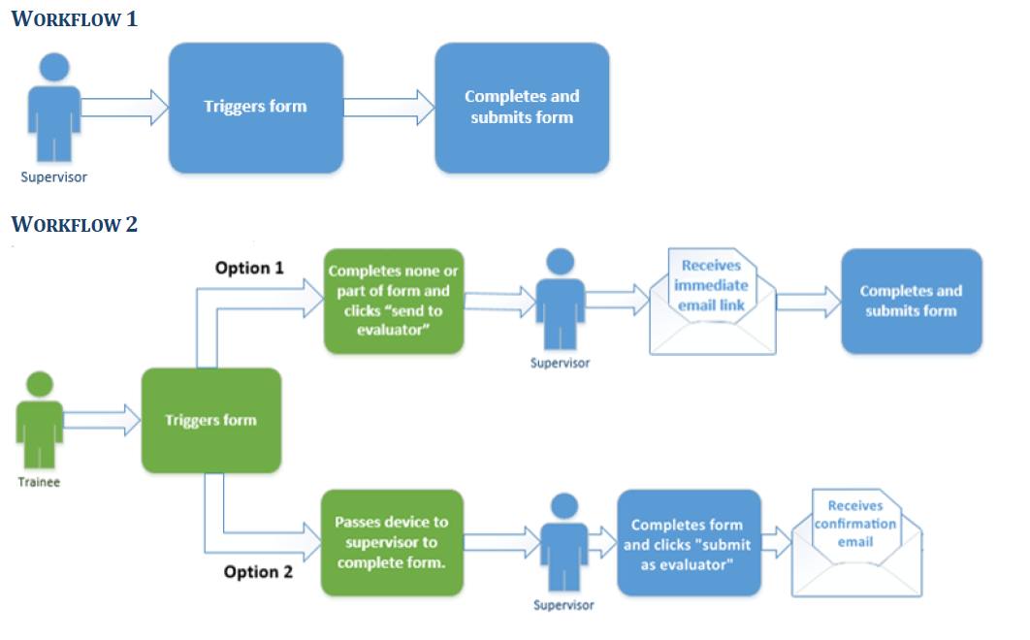

There are training videos and documentation on the MedSIS Website: https://healthsci.mcmaster.ca/medsis/training/cbme to assist you in getting started.
From a Supervisor’s perspective:
How to trigger and complete a CBD form on my mobile device.
- How to login to MedSIS on my mobile device
- How to bookmark MedSIS on my iphone for easy access
- How to login to MedSIS on my mobile device using my MacID credentials
- How to access and complete a CBME form sent to me by a trainee on my mobile device
- How to trigger and complete a CBME form on my mobile device
- How to filter my existing assessments on my mobile device.

Faculty Competence #4
“Know how to determine which tool should be used on a given day and who initiates the ASSESSMENT process”

Traditional model program
Briefly describe the assessment tools your program will use to assess your TM residents throughout the transition to CBD.

CBD program
As you know, the [your specialty name] clinical curriculum is defined by [Number of Total EPAs in program] EPA’s, with [number of TTD EPA] of them situated in the first phase (TTD).
As we learned in Faculty Competence #1, the teaching and learning during TTD must extend beyond the TTD EPA’s. If we assessed only TTD EPA’s, the importance of the rich learning that happens outside those EPAs, discrete activities would be de-emphasized. These are new residents, and they will look to us to form their understanding of what is important in our specialty. The flowsheet on the next page describes the assessment process. Some key points to remember:
- [Modify statement as required] Only one form of assessment each day
  - Decided at the outset
  - Decision made collaboratively between faculty and resident
  - Assessment must be flexible and responsive to unexpected events (see Faculty Competence #7 for more on this!)
- Each EPA must be observed a specific number of times (by different observers) before it is considered “completed” or successfully performed. The number of observations is written into the EPA definition, by the Royal College, is specific to the EPA, and is to be used as a guideline.
- The Competence Committee (CC) considers all forms of assessment in determining the resident’s progress.
The resident is best positioned to understand their progress on their required EPAs: which ones they are ready to be assessed on, which ones that are already complete. However, the faculty may be better able to assess what sort of assessment opportunities may present within a given list. Over time, the process of balancing these two very different types of assessments will likely become more organic but the flowchart can provide some guidance.
Describe other assessment tools that will be used by your program for CBD residents, feel free to incorporate their use into the flowchart below.

Flowchart of Assessment Process
Resident or Staff feels that EPA assessment is warranted
Unexpected event occurs
Assessment conducted. Form accessed on MedSIS by either resident or staff
Staff and Resident agree on appropriate patient to demonstrate/assess EPA
Teacher accepts
Resident feels prepared to “challenge“ an EPA
Resident “practicing” elements of EPA
Resident working with staff member

Faculty Competence #5
Understand the different types of rating scales used within each tool:

ASSESS THE EPA (OVERALL) AS WELL AS THE COMPONENT MILESTONES
EPA Assessments
The EPA’s and their assessment tools have been created by the Royal College and Specialty Committee in your specialty name and are being used by your specialty name programs across the country. The EPA is specific to the stage of training and is achievable at the level of competence by a resident at that level of training. The EPA is described in a summary form, usually in one sentence. For example, TTD-1:
TTD-1: your specialty’s TTD-1 EPA
The assessment tool will ask you to observe and assess the overall performance level of the EPA using an Entrustability scale. You should be familiar with the Entrustability scale:
Level | Anchor | Descriptor
1 | “I had to do” | The physician had to perform the clinical activity while the resident observed.
2 | “I had to talk them through” | The resident required constant direction.
3 | “I had to prompt them from time to time” | The resident required frequent direction.
4 | “I had to provide minor direction” | The resident required minor direction.
5 | “I did not need to provide direction for safe and independent care” | No direction was required for safe independent care.

Some important points about EPA assessment:
- The EPA is assessed as applied to the performance in one case, one patient, not as a summation of the day as a whole.
- It is decided in advance which case is going to be assessed. This way, we avoid bias in decided retrospectively which case to choose (do you choose their best performance? Their weakest? The average?)
- The observer must assess the performance based on what they see in that performance- not what they have observed that resident do on other days, or what they think the resident can do on a good day
- The EPA assessment is a needle biopsy, not a CT scan
- Giving a resident less than the “Didn’t have to be there” rating, does not mean the resident fails the rotation. If you assess them as less than fully independent, it is an opportunity for them to learn and improve and demonstrate true competence to another observer the next time
- The resident is required to achieve several successful observations (usually 3-5) for that EPA to be complete.
- The narrative comments are the most valuable information. Good comments provide residents with detailed guidance for improvement.
EPA Assessments: Milestones
Each EPA has a list of associated milestones. Milestones are component abilities that are used to perform the EPA. Milestones are defined by CanMeds competency, were created by the RC, and are shared across all specialties. With an EPA assessment, you are asked to also assess at least ONE of the component milestones. Each milestone should be assessed as “in-progress”, “achieved” or “not observed”.
- The assessor assigns an overall assessment (entrustability) as well as assesses the component milestones
- The overall EPA cannot be considered successful if one of the milestones was still “in-progress”.
- If the Overall Assessment of the EPA is less than “I didn’t need to be there”, then looking at which milestones are still “in progress” can assist the program in knowing what the resident needs help with
TTD-3: your specialty’s TTD-3 EPA
Include a screenshot/picture of milestone assessment for TTD-3 EPA

Faculty Competence #6

“SUccessfully submit the completed ASSESSMENT tool”
The mechanics of assessment submission is easy.
Some key points:
- CBME Assessments should be completed the same day.

In MedSIS CBME forms will have a 7 day expiry date from when the form is triggered.

It is critical that forms are declined so they can be redistributed to the correct person. When an assessment is received, the supervisor has the option to ‘Start’ the form or to ‘Decline’ it. If the assessment has been sent to the wrong individual the assessment should be ‘Declined’. The comment field should be used to explain why the form is being declined.

- CBD will require Faculty and resident to plan space and time for assessment.

- The discussion with the resident is one of the most important aspects for resident learning.

Faculty Competence #7

“Know what to do if the unexpected happens during the day- how to change the ASSESSMENT plan”

Imagine a scenario that might occur when we have senior CBD residents:
Scenario can be changed to suit your specialty
You and the resident have decided on the EPA assessment for your day together. Then, with the third patient, an unexpected difficult intubation is encountered. These clinical events cannot be planned in advance. If the opportunity to assess one of these EPA’s (difficult airway, resuscitation, disclosure of adverse event) occurs, then the assessment plan should be flexible enough to take advantage of it.
The EPA assessment for these unexpected events can supplant the planned assessment, or it can be added as a second assessment. The number of assessments completed on a given day is not restricted, but we are cognizant of not wanting Faculty to suffer from assessment burn-out.

The flowchart on page 16 includes a pathway whereby an unexpected event can be incorporated into the assessment plan. The bottom line is that the assessment plan should be determined at the start of the day but it should also be flexible and responsive to the occurrence of unusual events. A single day can result in multiple assessments (but only one daily encounter) but as with most things, quality is more important than quantity.

Faculty Competence #8

“be familiar with the narrative form: when to use it and how to access it”

We have focused on the main types of clinical assessment tools that will be replacing our name of assessment tools currently used in your program that is currently in use.
There is another type of assessment tool that the Royal College has developed for CBD: the “Narrative Form”. The Narrative form is designed for use in the instance where the supervising Faculty would like to communicate some important feedback, either positive or negative, directly to the Competence Committee or Program Director. It is a form with space for comments only (no scoring).
The purpose of the Narrative Form is to introduce a method of formalizing and documenting the “hallway conversation”. Currently, when a Faculty member comes to the PD to describe an exceptional encounter (positive or negative), the PD would ask the Faculty to email the details to him/her. It would be discussed with the resident and included in the resident file for that rotation and would form part of their rotation assessment. The new Narrative Form provides a formal route for this form of feedback.
It is encouraged that any exceptional encounter be documented by the assessor with a Narrative form, including instances where the resident performed exceptionally well. The flowchart below describes the use of the Narrative form, and shows pathways for confidential (right) and non-confidential (left) submission.
In MedSIS, there are narrative forms that are linked to an EPA, as well as non-linked narrative forms.

Providing Comments Regarding an Unexpected Event
Resident working with staff
Staff & Resident decide on EPA

An unexpected event (positive or negative) occurs

Staff discusses event and feedback with resident
Staff approaches PD/CTU director to discuss resident’s performance

Staff accesses form on MedSIS

Staff completes narrative assessment (includes concerns and/or positive comments)

Summary notes for the 8 Faculty Competencies
- TTD is length of your specialty’s TTD phase and is associated with the EPA’s that should be achievable by early residents. Teaching and assessment is not limited to the EPA’s.
- There will be number of assessment tools used by your program types of assessment tools: the EPA assessment and name of other assessment tools used by your program.
- All assessment tools are electronic and accessed on MedSIS.
- CBD residents are assessed with EPA assessments and name of other assessment tools used by your program. The choice is a collaborative decision and it is suggested that EPA’s be assessed when they have had enough experience to perform it independently. TM residents are assessed with name of assessment tools used for TM residents.
- EPA assessments:
  - The overall EPA is assessed with an Entrustability scale
  - The Milestones are assessed as “complete” or “in progress”
Briefly describe any other assessment tools that your program will use for CBD
- Complete the assessment by logging into MedSIS at the end of the day. Assessment takes planning for both time and space.
- The type of assessment (for CBD residents) should be decided at the beginning of the day, but can be changed if an “assess-able” moment arises (e.g. Difficult intubation).
- The Narrative form is also available on MedSIS and is used to describe an exceptional occurrence- positive or negative.

Final Words
Thank you for reading this and for your ongoing support of the Residency Program through this transition. There will undoubtedly be bumps along the road, as we all figure this out together- being flexible and maintaining a sense of humour will be key! As much as we have focused on the imminent changes, let’s remember that the fundamentals are not changing. Residency will still be an apprenticeship, involving exposure of novices to experts, over time. CBD uses “Competency” as a noun, the individual activities that we perform but “Competency” also describes the level of performance. With CBD, we ensure that residents achieve “Competence” as defined by the EPAs by the end of their training. The curve below shows that residents continue to develop over the ensuing decade or more.

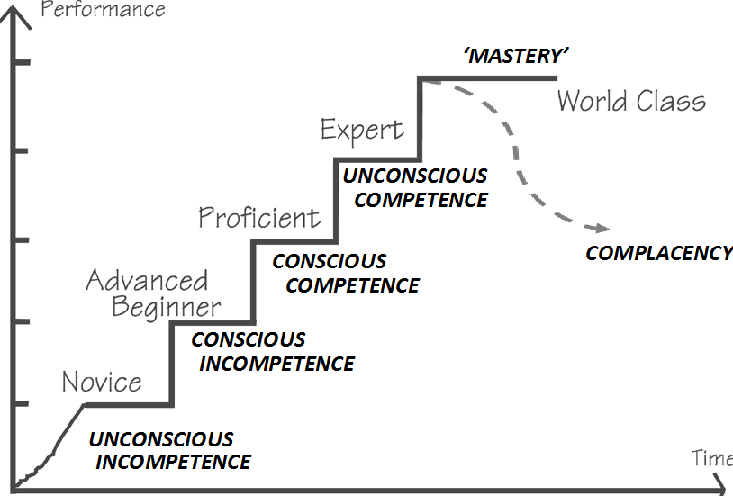

Resources
RCPSC CBD Resource Directory
McMaster CBME website
MacHealth
Available on MacHealth are CBD 101 course modules, developed by the Postgraduate Medical Education office at McMaster.

MedSIS training tools

