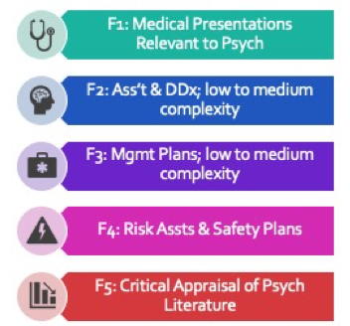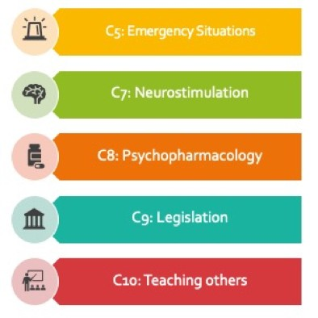CBME
Newsflash!
EPAs
for
P G Y 2 Y E A R O F
F O U N D A T I O N S S T A G E O F T R A I N I N G

Residents must achieve the 5 Foundations EPAs by the end of Pgy2.

‹‹‹REPLACE WITH YOUR PROGRAM’S EPAS›››

Residents may work on Core EPAs relevant to experiences
encountered in Pgy2.

