CBME
Newsflash!

begins in block 3 of pgy1 runs to the end of pgy2
T H E
FOUNDATIONS of DISCIPLINE
Stage of Training

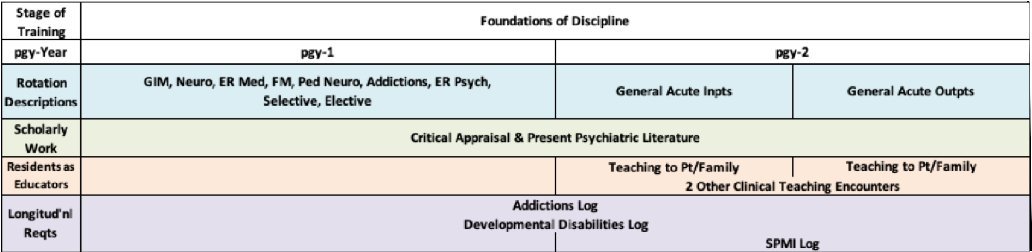lays the groundwork of knowledge and skills for psychiatry highlights management of relevant medical presentations
builds psychiatric assessment & management skills, for patients of low to
medium complexity.

