Transition to Discipline (TtD) Resident Guide

Resident Name

Overview

The Transition to Discipline Stage of Training will provide you with an orientation to our program, the university, and the local health care system. It will also provide a review and assessment of the basic skills required to begin residency training in Psychiatry.

“The secret to getting ahead, is getting started.”
-Mark Twain

It is strongly recommended that residents not take vacation during Transition to Discipline due to the short time frame, required assessments and importance of content being reviewed.

Table of Contents

Topic | Page #
Contacts | 3
Save the Date! | 4
Objectives of the Transition to Discipline Stage | 5
General Expectations of Residents in TtD | 6
Skill Expectations of Residents in TtD | 6
Rotation Design | 7
TtD Classroom Part 1 | 7
Clinical Psychiatry Experiences | 8
On-Call Duties during TtD | 9
TtD Classroom Part 2 | 10
Clinical Rotation Experiences | 10
Entrustable Professional Activities (EPAs) | 11
Assessment Tools for TtD | 15
Rotation Feedback | 16
Appendix A | 17
Appendix B | 18

Contacts

Position | Name | Email | Phone
Program Director | JoAnn Corey | jcorey@stjoes.ca | 905-522-1155 x39320
Program Administrator | Cheyenne Reid | creid@mcmaster.ca | 905-522-1155 x36659
Program Assistant | Meaghan Duffy | duffym@mcmaster.ca | 905-522-1155 x36809
TtD Classroom Coordinator | Dr. Sandra Westcott | sandra.westcott@medportal.ca
TtD Classroom Faculty Supervisor | Dr. Laura Rosato | rosatol@hhsc.ca
Your Academic Coach
PES Medical Lead | Dr. Dave Fudge | dfudge@stjoes.ca | 416-475-3738
Hamilton On-Call Chief Resident | Dr. Liz Lovell | elizabeth.lovell@medportal.ca
Clinical Supervisor 1
Clinical Supervisor 2
Safety Chair | Dr. Jessica Vanderveen | jvanderv@stjoes.ca

Save the Date!

We hope you can join us for this casual event, designed for our new residents to meet other residents and faculty within our department.
Dinner will be on us this night!

Objectives of the Transition to Discipline Stage

The objectives of the Transition to Discipline Stage of Training are to:
- Become oriented with the McMaster Psychiatry Postgraduate Program, its faculty & resources
- Become oriented with CanMEDS roles
- Become oriented with Competency Based Medical Education
- Familiarize self with local health care system
- Gain training in use of electronic medical record
- Develop basic psychiatric interviewing skills including mental status exam and risk assessment
- Develop skills in documentation and order writing
- Become oriented with safety processes and policies relevant to healthcare workers, as well as safety strategies working within Psychiatry.
- Become oriented to the psychiatric emergency service in which you will be working
- Begin to develop skills in conducting emergency psychiatric assessments
- Begin to develop de-escalation techniques
- Gain knowledge of & begin to apply concepts of:
  - Institutional policies
  - Legislation relevant to the practice of Psychiatry in Ontario
  - De-escalation techniques
  - Diagnostic classification systems
  - History of Psychiatry
  - Psychiatric phenomenology
  - Stigma, marginalization & vulnerability
  - Cultural awareness
  - Appropriate use of social media & smart technology
  - Strategies for physician wellness

General Expectations of Residents in TtD

During the Transition to Discipline Stage of Training, residents are expected to:
- Attend all clinical days, unless ill.
- Be punctual.
- Notify clinical supervisors of any days / times they will be absent, in advance of the absence whenever possible.
- Be an active member of all clinical teams with which they are working
- Be an active participant in their learning. Identify key topics of interest & personal learning objectives and take initiative in gaining knowledge & skill in those areas
- Take shared responsibility in identifying opportunities for observation and feedback on EPAs
- Be receptive to feedback & work to incorporate recommendations for knowledge & skill development
- Demonstrate awareness of clinical responsibilities.
- Complete documentation in a timely manner that provides effective communication and continuity in patient care.
- Be aware of their limitations. Inform their supervisor whenever they are outside of their knowledge or skill level.
- Do not take patient material home.
- Conduct themselves in a professional manner, including use of social media & smart technology
- Complete all evaluations in a timely manner

Skill Expectations of Residents in TtD

By the end of the Transition to Discipline Stage, a resident should be able to:
- Demonstrate understanding of key safety strategies in conducting psychiatric interviews
- Demonstrate understanding of the key components of a basic psychiatric interview
- Conduct a basic psychiatric assessment with a patient of low complexity
- Conduct a basic risk assessment
- Conduct a basic emergency psychiatric assessment
- Demonstrate understanding of the elements of a Mental Status Exam
- Provide a verbal case presentation for a patient of low complexity
- Document in written/electronic form, a psychiatric assessment including basic, initial DDx and initial steps in a management plan

Rotation Design
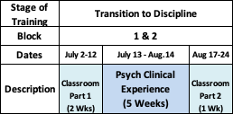

July 2 – 12, 2020 TtD Classroom Part 1

- Though your residency officially begins on July 1, 2020, you will not have any scheduled activities or clinical work on July 1, 2020. Happy Canada Day! 🇨🇦
- The first two weeks of your training will be “classroom based”. (refer to Appendix A for Syllabus)
- Sessions will primarily be completed via Zoom Videoconference due to pandemic conditions. A few, small-group sessions will be run at St. Joseph’s Healthcare, West 5th Campus in Hamilton, and for our WRC Residents, at sites within the Waterloo Regional Campus.
- Residents are expected to attend all sessions. Residents will be expected to make up any missed sessions by completion of an independent project.
- All assignments and projects must be completed. Projects & presentations will be evaluated.
- You will not be scheduled for on-call duties during Classroom Part 1

July 13 – August 14, 2020 Clinical Psychiatry Experiences

- During this time, you will gain experience working in an adult, psychiatric clinical service. This may involve one or two different preceptors/locations. This is an opportunity to:
  - observe clinical encounters
  - complete basic psychiatric assessments
  - practice verbal case presentations
  - complete documentation and order writing
  - develop basic differential diagnoses
  - develop initial steps in management plans

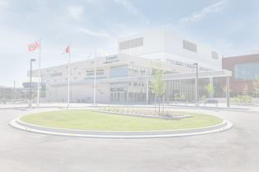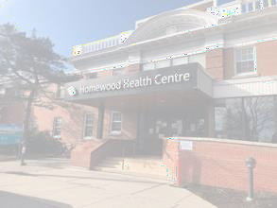
Hamilton Campus Residents
Waterloo Regional Campus Residents

- One 2-week and one 3-week placement
- Inpatient & Outpatient experiences
- ½ day/wk PES daytime shift
- No post-call days away from rotation
- 4 weeks inpatient experience at Homewood on Trillium Unit
- 1-week emergency psych / SSU experience
- No post-call days

- Clinical rotations will begin on Monday, July 13, 2020
- Residents are expected to be on rotation Monday, Tuesday, Wednesday mornings, Thursday and Friday each week
- On Wednesday afternoons residents are expected to attend Academic Half Days via Zoom Videoconference. Details of Academic Half-Days are included in the TtD Syllabus (see Appendix A)
- Hamilton Residents will spend ½ day per week (during the clinical weeks) in the Psychiatric
Emergency Service at St. Joseph’s Healthcare, Charlton Site
- WRC Residents will spend one of the clinical weeks in Emergency Psychiatry and/or the Short Stay Unit (SSU) at Guelph General Hospital & Homewood. Due to location changes with the SSU due to CoVID, its exact location will be confirmed with at the start of TtD. (Rest easy - GGH & Homewood are just across the street from each other)

On-Call Duties during TtD:
On-Call during Transition to Discipline will be in Emergency Psychiatry

Hamilton:
- Call will be at the Psychiatric Emergency Service (PES) at SJH, Charlton Site
- You will not be on call prior to July 24th, to enable time for orientation and training in foundational skills.
- You will always be on call with at least one senior resident. There is always a staff psychiatrist on call.
- Mondays, Wednesdays and Thursdays: you will be the third resident joining the On-Call resident team. Your shift will end at 11pm so that there will be no post-call days away from rotation.
- Fridays: you will also be a third resident joining the On-Call resident team, however your shift will be overnight until 9am Saturday morning
- Sundays and Holiday Monday August 3rd: you will be the third resident on the On-Call resident team, working 9am to 9pm, so that you will be able to attend your clinical placement the next day.
o Exception: Sunday, August 2nd: the resident on call this date will complete an overnight shift, from 9am Sunday to 9am Monday. This will be considered in the allotment of call stats.

WRC:
- Call will be in Emergency Psychiatry at Guelph General Hospital
- You will not be on call during either Classroom Part 1
- You will always be buddied with a senior resident
- There is always a staff psychiatrist on call
- You will have approximately 3 on-call shifts, with one of them being on a weekend day
- On-call shifts end at 11pm, so there will be no post-call days

August 17 – 24, 2020 TtD Classroom Part 2

- The last week of TtD will again be “classroom based”. (refer to Appendix A for Syllabus)
- Sessions will primarily be completed via Zoom Videoconference due to pandemic conditions. A few, small-group sessions will be run at St. Joseph’s Healthcare, West 5th Campus in Hamilton, and for our WRC Residents, at sites within the Waterloo Regional Campus.
- Residents are expected to attend all sessions. Residents will be expected to make up any missed sessions by completion of an independent project.
- All assignments and projects must be completed. Projects & presentations will be evaluated.

Clinical Rotation Experiences

Your clinical rotations will be:

July 13-17
July 20-24
July 27-31
Aug 3-7
Aug 10-14

Hamilton Residents:

You will have daytime shift in PES on:
o

Entrustable Professional Activities (EPAs)
By the end of the Transition to Discipline Stage, residents should have had the opportunity to demonstrate performance for the two Entrustable Professional Activities (EPAs) corresponding to this stage of training: TtD EPA #1 and TtD EPA #2 (see below).

Assessment of an EPA should be documented using an EPA Assessment form,
located on MedSIS.

For MedSIS Instructions for use on Mobile Devices: https://healthsci.mcmaster.ca/medsis/training/cbme

For MedSIS Instructions to Trigger a WBA on Desktops: https://healthsci.mcmaster.ca/docs/librariesprovider30/training/pgme/students/how-to---trigger-on- demand-evalautions.pdf?sfvrsn=6667a62_2

(Examples of the EPA Assessment forms for the Transition to Discipline EPAs can be found in Appendix B.)

Residents should be assessed on their EPA performance using the descriptors on the Entrustment Scale, indicated on the EPA Assessment form.
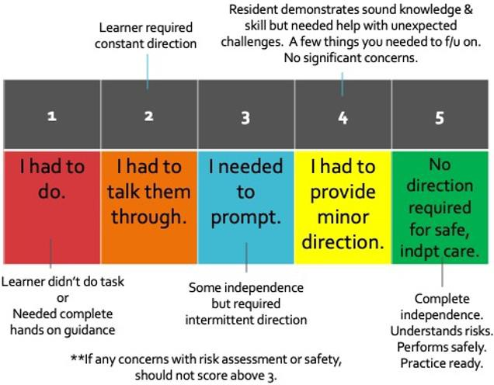

It will take likely take two to three attempts to gain a successful EPA observation, so be sure to start requesting your supervisor to assess you doing an EPA early on in your clinical experience.

IN ADVANCE of doing the clinical task, discuss with your supervisor/observer of the task, that they might assess your work. Such assessments should:
- Involve direct or indirect observation by the assessor
- Be followed by in the moment, face to face verbal feedback after completion of the clinical task
- Be followed by completion of the electronic Workplace Based Assessment** form (WBA)

**EPAs should be completed even if completion of the task was rated less than a 4 or 5, in order to foster feedback and development.

Remember! The most important part of the EPA is the Feedback Section

The 2 EPAs which residents must successfully complete during the Transition to Discipline stage are outlined on the next two pages*.

EPA TtD #1
Obtaining a psychiatric history, which includes a preliminary diagnostic impression for patients presenting with mental disorders.

Key Features:
- This EPA verifies medical school skills of obtaining a psychiatric history and synthesizing information for diagnosis
- This includes clinical assessment skills, including a mental status examination and a focused physical/neurological exam if clinically indicated, and synthesizing a preliminary diagnostic impression in a patient of low complexity.
- This EPA may be observed in any psychiatry setting.

Assessment Plan:
- Direct observation by a psychiatrist/subspecialty psychiatrist, Core/TtP psychiatry/subspecialty (senior) psychiatry resident or fellow

- Use MedSIS Form. Form collects information on:
  - Case type: anxiety disorder; cognitive disorder; mood disorder; neurodevelopmental disorder; personality disorder; psychotic disorder; substance use disorder; other

- Collect 2 observations of achievement:
  - At least 2 different case types
  - At least 1 by psychiatrist
Relevant Milestones:
- ME 1.3 Apply Diagnostic classification systems for common mental disorders
- ME 2.2. Perform a clinically relevant history including ID, HxPI and PastPsychHx
- ME 2.2 Perform a focused physical and/or neurological exam as clinically relevant
- ME 2.2. Develop a specific differential diagnosis relevant to the patient’s presentation
- ME 2.2. Conduct a mental status examination
- ME 2.4. Develop an initial management plan for common patient presentations
- COM1.1 Convey empathy, respect, and compassion to facilitate trust & autonomy
- COM1.4 use appropriate non-verbal communication to demonstrate attentiveness, interest, and responsiveness to the patient & family
- COM 2.3 Seek & synthesize relevant information from other sources, including the patient’s family, with the patient’s consent
- COM 4.1. Conduct an interview, demonstrating cultural awareness
- P 1.1. Demonstrate awareness of the limits of one’s own professional expertise

TtD EPA #2

Communicating clinical encounters in oral and written/electronic form.

Key Features:
- This EPA includes presenting a case in a succinct and systematic manner, including all relvant details (such as mental status exam, issues of risk, information relevant to handover), and providing written/electronic documentation of the encounter and the management plan using a relevant structure and heading.
- This includes using appropriate psychiatric terms/phenomenology
- This EPA does not include developing the management plan.
- The observation of this EPA is based on an oral presentation of an assessment and review of written/electronic documentation.
- This EPA may be observed using a clinical patient encounter, a standardized patient, a recorded encounter, a written case or other formats.

Assessment Plan:
- Direct observation of verbal presentation and review of written/electronic communication observation by a psychiatrist/psychiatric subspecialist, Core/TtP psychiatry/subspecialty (senior) resident or fellow or other attending physician.
  - Note: entirety of patient encounter does not need to be observed to assess this EPA
- Use MedSIS Form. Form collects information on:
  - Portion observed (select all that apply): history, verbal presentation; written/electronic documentation

- Collect 2 observations of achievement:
  - At least 1 of each presentation format, verbal and written
  - At least 1 observation must be based on an interview that was observed
  - At least 1 by a psychiatrist
Relevant Milestones:
- ME 2.2. Synthesize clinical information for presentation to supervisor
- COM 5.1 Document the mental status exam accurately
- COM 5.1 Document an accurate and up-to-date medication list
- COM 5.1 Document information about patients and their medical conditions
- COL 2.1. Convey information respectfully to referral source
- COM 5.1. Organize information in appropriate sections within an electronic or written medical record
- COL 3.1 Describe specific information required for safe handover during transitions in care

Assessment Tools for TtD (refer to Appendix B)

Task | Assessment Tool | Assessor
Overall Classroom Performance | ITAR (In-Training Assessment of Resident) | Dr. Rosato, with input from  Dr. Westcott & session facilitators
EPAs | EPA Assessment Form. (accessed through MedSIS)* | Person observing you (directly/indirectly) completes the EPA
Clinical Rotation Experience | ITAR (In-Training Assessment of Resident). Will be sent to supervisor via MedSIS. | Each clinical supervisor
Psychiatric Emergency Clinical Work | Emergency Psychiatry Evaluations. (completed via MedSIS) | Faculty supervisor for each on call
History of Psychiatry Project | Project Presentation Evaluation Form | Dr. Westcott, Dr. Rosato, Dr. Corey
Controversies in Psychiatry Assignment | Project Presentation Evaluation Form | Dr. Westcott, Dr. Rosato, Dr. M. Bennett
Evidence-Based Medicine Project | Project Presentation Evaluation Form  and  EPA F5 WBA form | Dr. Streiner, Dr. Charlebois, Dr. Prosser, Dr. Westcott

Rotation Feedback

Feedback from our residents is imperative to our ongoing review & revision of the program, and faculty development. It is also a requirement for the process of Tenure and Promotion of faculty members.
For these reasons, completion of all evaluations is asked of our residents. Thank you in advance for taking the time to provide useful feedback.

At the end of each day, you will be asked to complete:
- An evaluation of the academic sessions

At the end of each of your clinical rotation experiences, you will be asked to complete:
- An evaluation of the rotation (i.e. about the experience in general)
- An evaluation of the faculty supervisor

At the end of the Transition to Discipline Stage of Training, you will be asked to complete:
- An evaluation of the Transition to Discipline experience

APPENDIX A
TtD Classroom Curriculum Syllabus
The Syllabus of sessions for the Transition to Discipline Classroom Curriculum can be found via the following link:
https://drive.google.com/drive/folders/1tdUBS8UUf4BCI4C-2v8hD6Qle7kKCTrx?usp=sharing

You will find other documents including project assignments on that google drive as well.

APPENDIX B
Transition to Discipline Evaluation Forms
EPA Assessment Form for TtD EPA #1

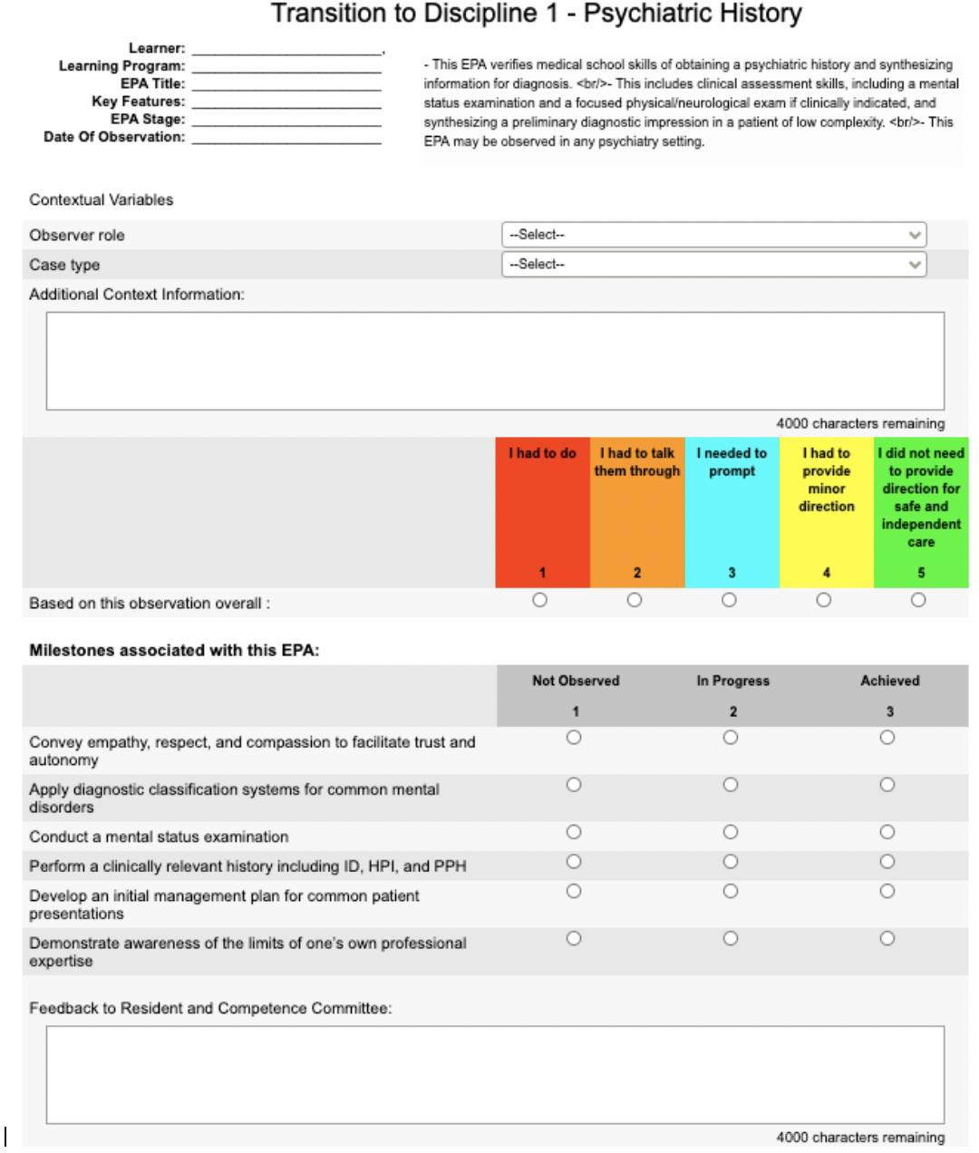

EPA Assessment Form for TtD EPA #2

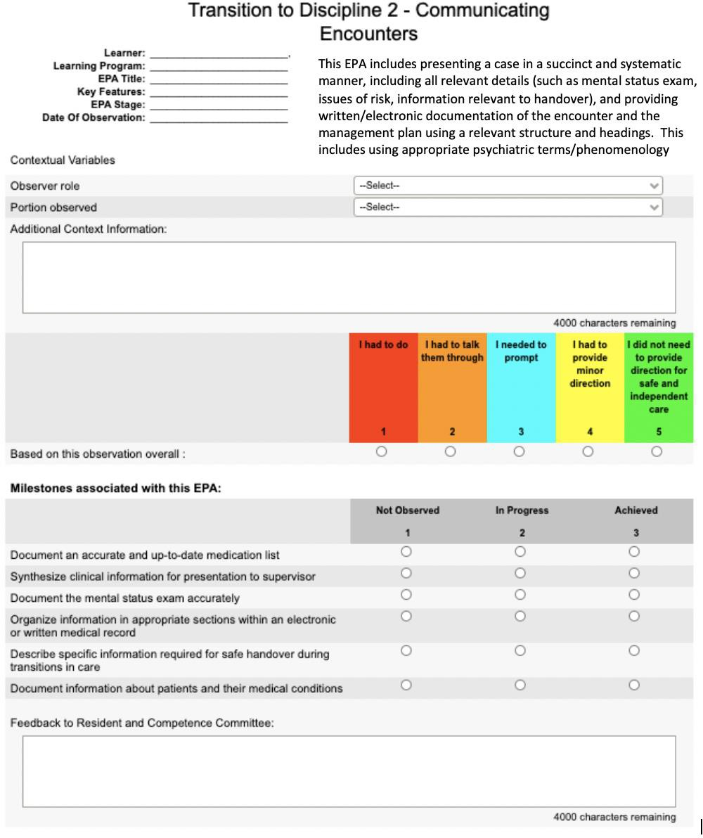

In-Training Assessment Report (ITAR)

Rotation: Transition to Discipline Psychiatry Clinical Rotation

Legend:

N/A=Non Applicable
1= Unsatisfactory: Performs significantly lower than level of training 2= Provisional Satisfactory: Performs lower than level of training
3= Satisfactory: Meets expectations at level of training 4= Very Good: Exceeds Expectations for level of training
5= Outstanding Significantly exceeds expectations for level of training

NOTE: If resident functions at training level, then resident obtains score of (3)

Medical Expert:

 | N/A | 1 | 2 | 3 | 4 | 5
Shows basic clinical knowledge of common psychiatric presentations.
Conducts a basic psychiatric interview, including mental status exam and risk
assessment, with patients of low complexity with common psychiatric presentations.
Develops basic differential diagnoses for
patients of low complexity with common psychiatric presentations.
Begins to develop initial steps of management plan for patients of low complexity with common psychiatric
presentations.

Communicator:

 | N/A | 1 | 2 | 3 | 4 | 5
Uses clear, unbiased language in interactions with patients, families and other
health care professionals
Uses appropriate non-verbal communication to demonstrate attentiveness, interest and responsiveness to patients & families
Appropriately communicates findings in
verbal case presentations.

Appropriately communicates findings in written documentation in an organized
manner.
Develops comfort in writing basic orders for patient care.

Collaborator:

 | N/A | 1 | 2 | 3 | 4 | 5
Works respectfully with other health care professionals
Respects the diversity of perspectives and expertise among health care professionals
Responds to requests in a respectful & timely manner
Learning the information system for patient care

Manager:

 | N/A | 1 | 2 | 3 | 4 | 5
Aware of rotation learning objectives
Sets personal learning objectives
Shares learning objectives with supervisor at start of rotation
Organizes self effectively, appropriately using personal strategies & technology

Scholar:

 | N/A | 1 | 2 | 3 | 4 | 5
Demonstrates a commitment to learning
Receptive of feedback
Demonstrates incorporation of feedback
Takes initiative in gaining knowledge based on clinical encounters

Professional:

 | N/A | 1 | 2 | 3 | 4 | 5
Reliably attends to clinical responsibilities
Exhibits honesty & integrity with patients, supervisor and other health professionals

Maintains confidentiality as appropriate for the clinical encounter
Reflects on clinical experiences to identify personal goals for clinical skill development
Demonstrates commitment to health of individual patients through ethical practice, high personal standards of behaviour and reliability in attending to clinical
responsibilities.

OVERALL COMPETENCE (FOR LEVEL OF TRAINING)
Please check the appropriate box for the overall competency for this resident for his or her level of training.
Incomplete | Unsatisfactory | Provisional Satisfactory | Satisfactory

- Was input sought from other faculty, allied health team members, patients and families?
  - Yes No

- If yes, whom:

- What other sources were used to base this assessment ( eg field notes, daily assessment card, mini-cex etc)

Summative Comments: (any item evaluated above or below a 3 must include comments, including examples to justify the rating)
Formative Comments: Please provide 1-2 items for resident to work on to progress along the competency continuum

Transition to Discipline Psychiatry Curriculum Evaluation

This is in the process of being updated to this year’s curriculum.

The final version will be shared with you at the start of Classroom 1.

