Transition to Discipline (TtD) Faculty Guide

This guide may be used in conjunction with the introductory manual,

A Guide to CBME in the McMaster Psychiatry Postgraduate Program, June 16, 2020

Faculty Name, July 2020

Overview

The Transition to Discipline Stage of Training will provide residents with an orientation to our program, the university, and the local health care system. It will also provide a review and assessment of the basic skills required to begin residency training in Psychiatry.

“The secret to getting ahead, is getting started.”
-Mark Twain

Table of Contents

Topic | Page #
Contacts | 3
Your Supervision Dates | 4
Save the Date – Event to Welcome our Pgy1s | 5
Objectives of the Transition to Discipline Stage | 6
Rotation Design | 7
TtD Classroom Part 1 | 7
Clinical Psychiatry Experiences | 8
On-Call Experiences during TtD | 9
TtD Classroom Part 2 | 9
Entrustable Professional Activities (EPAs) | 10
General Expectations of Residents in TtD | 14
Skill Expectations of Residents in TtD | 14
Assessment Tools for TtD | 15
General Expectations of Supervisors | 16
Specific Supervisor Expectations | 16
Rotation Feedback | 17
Appendix A - TtD Evaluation Forms | 18

Contacts

Position | Name | Email | Phone
Program Director | JoAnn Corey | jcorey@stjoes.ca | 905-522-1155 x39320
Program Administrator | Cheyenne Reid | creid@mcmaster.ca | 905-522-1155 x36659
Program Assistant | Meaghan Duffy | duffym@mcmaster.ca | 905-522-1155 x36809
WRC Regional Education Lead | Dr. Shuang Xu | shuangxumd@gmail.com | 289-527-0095
WRC Program Administrator | Ashley Clark | clark1@mcmaster.ca | 519-885-5426 x21143
TtD Classroom Coordinator | Dr. Sandra Westcott | sandra.westcott@medportal.ca
TtD Classroom Faculty Supervisor | Dr. Laura Rosato | rosatol@hhsc.ca
PES Medical Lead | Dr. Dave Fudge | dfudge@stjoes.ca | 416-475-3738
Resident 1 You Are Supervising Date-Date | Name | email
Safety Chair | Dr. Jessica Vanderveen | jvanderv@stjoes.ca

Your Supervision Dates

Thank you for providing this first clinical experience for a pgy1 resident in our program!

Name of resident will be working with you enter dates.

Name of resident will be working with you enter dates.

Hamilton Supervisors:
Your resident will have daytime shifts in PES on:

Save the Date – Event to Welcome our Pgy1s

We hope you can join us for this casual event, designed for our new residents to meet other residents and faculty within our department.

Objectives of the Transition to Discipline Stage

The objectives of the Transition to Discipline Stage of Training are for residents to:
- Become oriented with the McMaster Psychiatry Postgraduate Program, its faculty & resources
- Become oriented with CanMEDS roles
- Become oriented with Competency Based Medical Education
- Familiarize self with the local health care system
- Gain training in the use of electronic medical record
- Develop basic psychiatric interviewing skills including mental status exam and risk assessment
- Develop skills in documentation and order writing
- Become oriented with safety processes and policies relevant to healthcare workers, as well as safety strategies working within Psychiatry.
- Become oriented to the psychiatric emergency service in which they will be working
- Begin to develop skills in conducting emergency psychiatric assessments
- Begin to develop de-escalation techniques
- Gain knowledge of & begin to apply concepts of:
  - Institutional policies
  - Legislation relevant to the practice of Psychiatry in Ontario
  - De-escalation techniques
  - Diagnostic classification systems
  - History of Psychiatry
  - Psychiatric phenomenology
  - Stigma, marginalization & vulnerability
  - Cultural awareness
  - Appropriate use of social media & smart technology
  - Strategies for physician wellness

Rotation Design
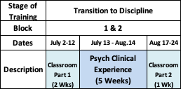

July 2 – 12, 2020 TtD Classroom Part 1
- The first two weeks of TtD Residents’ training will be “classroom based”. Sessions will include:

EMR Training | Basics of Psychiatric Interviewing | How to Present a Case
Intro to Mental Health Law | History of Psychiatry | Medical Clearance in the ER
Intro to Formulation | Management of Agitated Patients | Basic Note Writing
Basic Order Writing | Practical DBT Skills | Intro to EBM
Orientation to Program & Dept | Overview of Local MH Programs | CoVID Safety & Care
 | Controversies in Psychiatry

- Sessions will be primarily be completed via Zoom Videoconference due to pandemic conditions. A few small-group sessions will be run at St. Joseph’s Healthcare, West 5th Campus in Hamilton, and for our WRC residents, at sites within the Waterloo Regional Campus.

- TtD Residents will not be on call during the weeks of Classroom Part 1, to enable time for necessary training and orientation.

July 13 – August 14, 2020 Clinical Psychiatry Experiences

- During this time, residents will gain experience working in adult, psychiatric clinical services. This is an opportunity for them to:
  - observe clinical encounters
  - complete basic psychiatric assessments
  - practice verbal case presentations
  - complete documentation & order writing
  - develop basic differential diagnoses
  - develop initial management plans

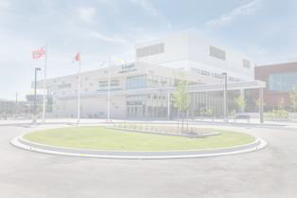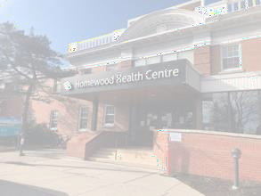
Hamilton Campus Residents
Waterloo Regional Campus Residents

- One 2-week and one 3-week placement
- Inpatient & Outpatient experiences
- ½ day/wk PES daytime shift
- No post-call days away from rotation
- 4 weeks inpatient experience
- 1-week emergency psych / SSU experience
- No post-call days

- Dates Away from Core Rotation Placement:
  - Residents will have Academic Half-Day on Wednesday afternoons. They are expected to be on clinical placements on Wednesday mornings.
  - All residents will be away from rotation on July 16th for CPI / Code White training
  - Hamilton Residents will be away from their core rotation ½ day per week to train in PES

- Please allow the resident to observe you doing clinical assessments, in addition to your observation of their clinical assessments.
- Some observations may be “indirect”, in that at your discretion, when safe to do so, residents may see some patients on their own and report back to you
- Please also provide feedback to residents on their documentation and order writing

(For expectations of placement supervisors, please refer to page 13.)

July 24 – August 24, 2020 On-Call Experiences during TtD

- Residents are expected to complete call shifts during TtD, however, will NOT be post-call during any of their classroom or clinical days
- At the beginning of the call shift, please:
  - Ask the resident about their prior experiences in emergency experiences. This will help inform your approach to their learning during the shift
  - Discuss opportunities to observe interview and/or documentation & complete EPA assessments.
- Emergency Psychiatry evaluations will not be completed on TtD Residents as these experiences focus on orientation and development of foundational skills as assessed by TtD EPAs #1 & #2

(For expectations of supervisors on-call, please refer to page 13)

August 17 – 24, 2020 TtD Classroom Part 2

- The last week of TtD will again be “classroom based”, as described above in TtD Classroom Part 1
- Residents will continue to gain experience in emergency psychiatry. However, they will be scheduled so as to not have any post-call days.

Entrustable Professional Activities (EPAs)
By the end of the Transition to Discipline Stage, residents should have had the opportunity to demonstrate performance for the two Entrustable Professional Activities (EPAs) corresponding to this stage of training: TtD EPA #1 and TtD EPA #2 (see below)

Assessment of an EPA should be documented using a EPA Assessment form,
located on MedSIS.

For MedSIS Instructions for use on Mobile Devices: https://healthsci.mcmaster.ca/medsis/training/cbme

For MedSIS Instructions to Trigger a WBA on Desktops: https://healthsci.mcmaster.ca/docs/librariesprovider30/training/pgme/students/how-to---trigger-on- demand-evalautions.pdf?sfvrsn=6667a62_2

(Examples of the EPA Assessment forms for the Transition to Discipline EPAs can be found in Appendix A.)

The resident should be assessed on their EPA performance using the descriptors on the Entrustment Scale, indicated on the EPA Assessment form.
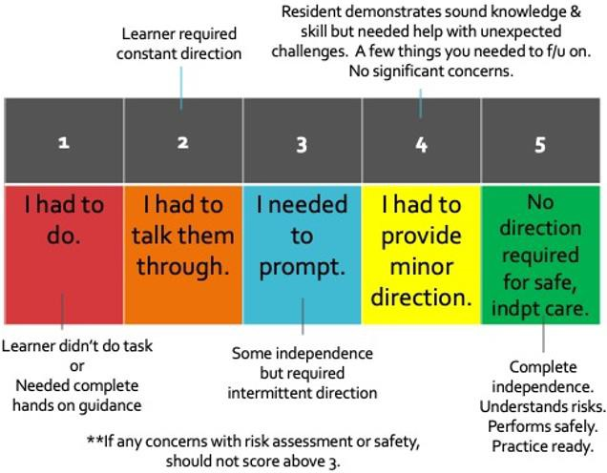

IN ADVANCE of doing the clinical task that is to be assessed, please discuss with the resident:
- The EPA being observed
- Expectations of time duration of observed activity
- What they should do if they are not sure how to proceed

Assessments may involve direct or indirect observation depending on variables such as the task at hand, patient complexity, your comfort level, and resident skill.
Assessments should be followed by:
- In the moment, face to face verbal feedback
- Completion of the written, electronic Workplace Based Assessment** form (WBA)

**EPAs should be completed even if completion of the task was rated less than a 4 or 5, in order to foster feedback and promote knowledge & skill development.
It is anticipated that it may take 2-3 attempts before a resident achieves a successful assessment.

Remember! The most important part of the EPA is the Feedback Section

Elements of feedback for a TtD resident should include:
- Close time proximity to the completion of the task
- Identify any strengths demonstrated
- Identify 1 -2 specific areas for development with concrete examples
- Outline specific strategies for resident to improve those areas for development
- Explain reasoning for score on Entrustment Scale
- Explain what would increase their Entrustment Score to the next number

The 2 EPAs which residents must successfully complete during the Transition to Discipline stage are outlined on the next two pages.

Obtaining a psychiatric history, which includes a preliminary diagnostic impression for patients presenting with mental disorders.

Key Features:
- This EPA verifies medical school skills of obtaining a psychiatric history and synthesizing information for diagnosis
- This includes clinical assessment skills, including a mental status examination and a focused physical/neurological exam if clinically indicated, and synthesizing a preliminary diagnostic impression in a patient of low complexity.
- This EPA may be observed in any psychiatry setting.

Assessment Plan:
- Direct observation by a psychiatrist/subspecialty psychiatrist, Core/TtP psychiatry/subspecialty (senior) psychiatry resident or fellow

- Use MedSIS Form. Form collects information on:
  - Case type: anxiety disorder; cognitive disorder; mood disorder; neurodevelopmental disorder; personality disorder; psychotic disorder; substance use disorder; other

- Collect 2 observations of achievement:
  - At least 2 different case types
  - At least 1 by psychiatrist
Relevant Milestones:
- ME 1.3 Apply Diagnostic classification systems for common mental disorders
- ME 2.2. Perform a clinically relevant history including ID, HxPI and PastPsychHx
- ME 2.2 Perform a focused physical and/or neurological exam as clinically relevant
- ME 2.2. Develop a specific differential diagnosis relevant to the patient’s presentation
- ME 2.2. Conduct a mental status examination
- ME 2.4. Develop an initial management plan for common patient presentations
- COM1.1 Convey empathy, respect, and compassion to facilitate trust & autonomy
- COM1.4 use appropriate non-verbal communication to demonstrate attentiveness, interest, and responsiveness to the patient & family
- COM 2.3 Seek & synthesize relevant information from other sources, including the patient’s family, with the patient’s consent
- COM 4.1. Conduct an interview, demonstrating cultural awareness
- P 1.1. Demonstrate awareness of the limits of one’s own professional expertise

TtD EPA #2

Communicating clinical encounters in oral and written/electronic form.

Key Features:
- This EPA includes presenting a case in a succinct and systematic manner, including all relvant details (such as mental status exam, issues of risk, information relevant to handover), and providing written/electronic documentation of the encounter and the management plan using a relevant structure and heading.
- This includes using appropriate psychiatric terms/phenomenology
- This EPA does not include developing the management plan.
- The observation of this EPA is based on an oral presentation of an assessment and review of written/electronic documentation.
- This EPA may be observed using a clinical patient encounter, a standardized patient, a recorded encounter, a written case or other formats.

Assessment Plan:
- Direct observation of verbal presentation and review of written/electronic communication observation by a psychiatrist/psychiatric subspecialist, Core/TtP psychiatry/subspecialty (senior) resident or fellow or other attending physician.
  - Note: entirety of patient encounter does not need to be observed to assess this EPA
- Use MedSIS Form. Form collects information on:
  - Portion observed (select all that apply): history, verbal presentation; written/electronic documentation

- Collect 2 observations of achievement:
  - At least 1 of each presentation format, verbal and written
  - At least 1 observation must be based on an interview that was observed
  - At least 1 by a psychiatrist
Relevant Milestones:
- ME 2.2. Synthesize clinical information for presentation to supervisor
- COM 5.1 Document the mental status exam accurately
- COM 5.1 Document an accurate and up-to-date medication list
- COM 5.1 Document information about patients and their medical conditions
- COL 2.1. Convey information respectfully to referral source
- COM 5.1. Organize information in appropriate sections within an electronic or written medical record
- COL 3.1 Describe specific information required for safe handover during transitions in care

General Expectations of Residents in TtD

During the Transition to Discipline Stage of Training, residents are expected to:
- Attend all clinical days, unless ill.
- Be punctual.
- Notify clinical supervisors of any days / times they will be absent, in advance of the absence whenever possible.
- Be an active member of all clinical teams with which they are working
- Be an active participant in their learning. Identify key topics of interest & personal learning objectives and take initiative in gaining knowledge & skill in those areas
- Take shared responsibility in identifying opportunities for observation and feedback on EPAs
- Be receptive to feedback & work to incorporate recommendations for knowledge & skill development
- Demonstrate awareness of clinical responsibilities.
- Complete documentation in a timely manner that provides effective communication and continuity in patient care.
- Be aware of their limitations. Inform their supervisor whenever they are outside of their knowledge or skill level.
- Do not take patient material home.
- Conduct themselves in a professional manner, including use of social media & smart technology
- Complete all evaluations in a timely manner

Skill Expectations of Residents in TtD

By the end of the Transition to Discipline Stage, a resident should be able to:
  - Demonstrate understanding of key safety strategies in conducting psychiatric interviews
  - Demonstrate understanding of the key components of a basic psychiatric interview
  - Conduct a basic psychiatric assessment with a patient of low complexity
  - Conduct a basic risk assessment
  - Conduct a basic emergency psychiatric assessment
  - Demonstrate understanding of the elements of a Mental Status Exam
  - Provide a verbal case presentation for a patient of low complexity
  - Document in written/electronic form, a psychiatric assessment including basic, initial DDx and initial steps in a management plan

Assessment Tools for TtD (refer to Appendix A)

Task | Assessment Tool | Assessor
Overall Classroom Performance | ITAR (In-Training Assessment of Resident) | Dr. Rosato, with input from  Dr. Westcott & session facilitators
EPAs | EPA Assessment Form. (accessed through MedSIS) | Person observing you  (directly/indirectly) completes the EPA
Clinical Rotation Experience | ITAR (In-Training Assessment of Resident). Will be sent to supervisor via MedSIS. | Each clinical supervisor
History of Psychiatry Project | Project Presentation Evaluation Form | Dr. Westcott, Dr. Rosato, Dr. Corey
Controversy in Psychiatry Assignment | Project Presentation Evaluation Form | Dr. Westcott, Dr. Rosato, Dr. M. Bennett
Evidence-Based Medicine Presentation | Project Presentation Evaluation Form  And  EPA F5 WBA Form | Dr. Streiner, Dr. Charlebois, Dr. Prosser, Dr. Westcott

General Expectations of Supervisors during the Transition to Discipline Stage of Training
Supervisors are also encouraged to refer to the McMaster Postgraduate Medical Education document,

“Supervision of Clinical Activities of PGME Learners”
During the Transition to Discipline Stage of Training, supervisors are expected to:
- Maintain sight of their role as physicians in providing the best possible patient care
- Always be available to the resident, in case of an urgent patient situation during regular work hours, including when providing indirect supervision.
- Actively engage residents in clinical activities and learning opportunities
- Take interest in residents’ learning objectives. Discuss with the resident at the start of the
placement their personal learning objectives.
- Take shared responsibility with residents to identify opportunities for observation and feedback including for EPA encounters.
- Regularly provide specific, actionable feedback to promote knowledge & skill development
- Allow the resident to attend all mandatory academic activities without guilt or fear of reprisal.
- Notify residents of any absences, as well as coverage arrangements
- Conduct themselves in a professional manner
- Complete all evaluations in a timely manner:
  - ITARs should be completed within one week of due date. (these expire after 60 days)
  - EPA Assessments should be completed within one day of the encounter. (these expire after 1 week)

Specific Supervisor Expectations:
Guidelines for supervisors to specific scenarios can be found in the following documents:
- Guidelines for Faculty Supervising Psychiatry Residents in PES, Junior to Senior Residency, April 6, 2020
- Guidelines for Faculty Supervising Psychiatry Residents On Call, Oct.1, 2019
- McMaster Psychiatry PG Program, Guidelines for Pandemic Supervision, April 6, 2020

Rotation Feedback

Feedback from our supervisors will be imperative to our ongoing review & revision of the program, and development of the Competency Based Medical Education curriculum. Thank you in advance for taking the time to provide feedback regarding the TtD Stage of Training.

At the end of the TtD Stage of Training, an evaluation form will be sent to you to collect your thoughts and suggestions on the clinical rotation portion of TtD.

APPENDIX A
Evaluation Forms for use in TtD

EPA Assessment Form for TtD EPA #1

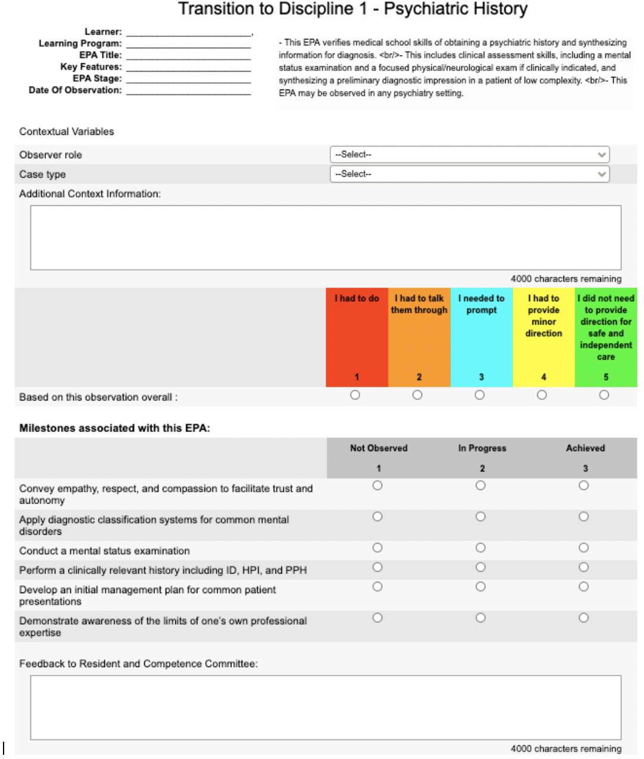

EPA Assessment Form for TtD EPA #2

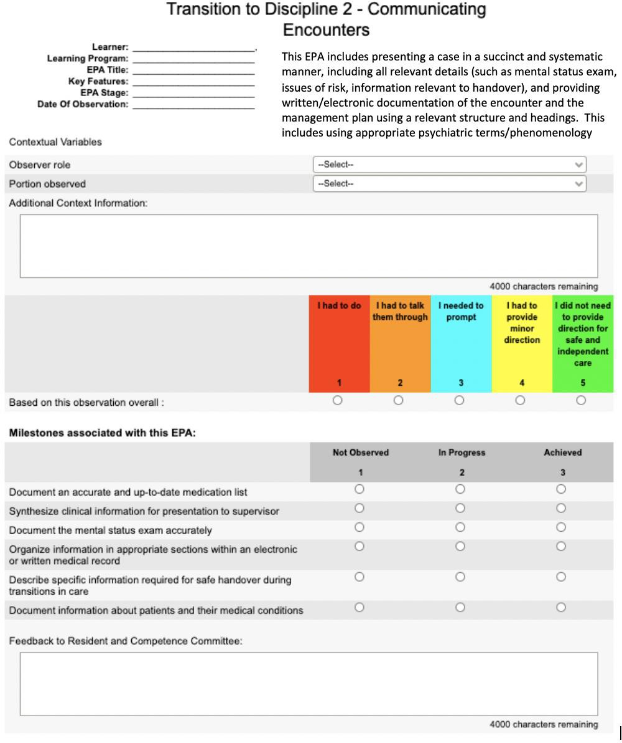

In-Training Assessment Report (ITAR)

Rotation: Transition to Discipline Psychiatry Clinical Rotation

Legend:
N/A=Non Applicable
1= Unsatisfactory: Performs significantly lower than level of training 2= Provisional Satisfactory: Performs lower than level of training
3= Satisfactory: Meets expectations at level of training 4= Very Good: Exceeds Expectations for level of training
5= Outstanding Significantly exceeds expectations for level of training

NOTE: If resident functions at training level, then resident obtains score of (3)

Medical Expert:
 | N/A | 1 | 2 | 3 | 4 | 5
Shows basic clinical knowledge of common psychiatric presentations.
Conducts a basic psychiatric interview, including mental status exam and risk assessment, with patients of low complexity
with common psychiatric presentations.
Develops basic differential diagnoses for patients of low complexity with common psychiatric presentations.
Begins to develop initial steps of management plan for patients of low
complexity with common psychiatric presentations.

Communicator:
 | N/A | 1 | 2 | 3 | 4 | 5
Uses clear, unbiased language in
interactions with patients, families and other health care professionals
Uses appropriate non-verbal communication
to demonstrate attentiveness, interest and responsiveness to patients & families
Appropriately communicates findings in verbal case presentations.
Appropriately communicates findings in written documentation in an organized
manner.
Develops comfort in writing basic orders for patient care.

Collaborator:
 | N/A | 1 | 2 | 3 | 4 | 5
Works respectfully with other health care professionals
Respects the diversity of perspectives and expertise among health care professionals
Responds to requests in a respectful & timely manner
Learning the information system for patient care

Manager:
 | N/A | 1 | 2 | 3 | 4 | 5
Aware of rotation learning objectives
Sets personal learning objectives
Shares learning objectives with supervisor at start of rotation
Organizes self effectively, appropriately using personal strategies & technology

Scholar:

 | N/A | 1 | 2 | 3 | 4 | 5
Demonstrates a commitment to learning
Receptive of feedback
Demonstrates incorporation of feedback
Takes initiative in gaining knowledge based on clinical encounters

Professional:

 | N/A | 1 | 2 | 3 | 4 | 5
Reliably attends to clinical responsibilities
Exhibits honesty & integrity with patients, supervisor and other health professionals
Maintains confidentiality as appropriate for the clinical encounter
Reflects on clinical experiences to identify personal goals for clinical skill development
Demonstrates commitment to health of individual patients through ethical practice, high personal standards of behaviour and reliability in attending to clinical
responsibilities.

OVERALL COMPETENCE (FOR LEVEL OF TRAINING)

Please check the appropriate box for the overall competency for this resident for his or her level of training.

Incomplete | Unsatisfactory | Provisional Satisfactory | Satisfactory

- Was input sought from other faculty, allied health team members, patients and families?
  - Yes No

- If yes, whom:

- What other sources were used to base this assessment ( eg field notes, daily assessment card, mini-cex etc)

Summative Comments: (any item evaluated above or below a 3 must include comments, including examples to justify the rating)

Formative Comments: Please provide 1-2 items for resident to work on to progress along the competency continuum

