Remember! The EPA assessment form will expire after 10 days.

CBME
Newsflash!
E P A XX

the
YOUR EPA HERE
EPA
NAME OF YOUR EPA HERE

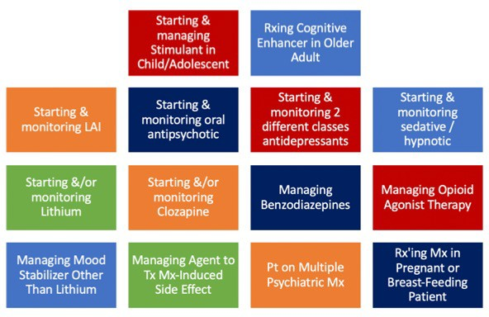
Residents are to be assessed doing each of the following:

Insert clinical opportunities relevant for your EPA and program here!
‹‹‹‹‹

