CBME/PGME
CBME Faculty Development Plan 2021-2022

Dr. Ereny Bassilious (Chair),Lisa Colizza,Jason Lamb

Table of Contents
Calendar of Events and Committee Meetings 2
Workshops 3
1. Curriculum Mapping Workshop 3
2. Direct Observation and Feedback 3
3. Retreat 4
4. Assessment Mapping Workshop 4
5. EPA Assessment: The Conceptual and the Practical 4
6. Introduction to Academic Coaching Workshop 1.0 5
7. Academic Coaching 2.0: Beyond the Basics 5
8. CBME Competence Committee Discussion Forum: Conundrums, Clarifications, Considerations 5
9. Competence Committee, Case Based Discussion 6

Calendar of Events and Committee Meetings

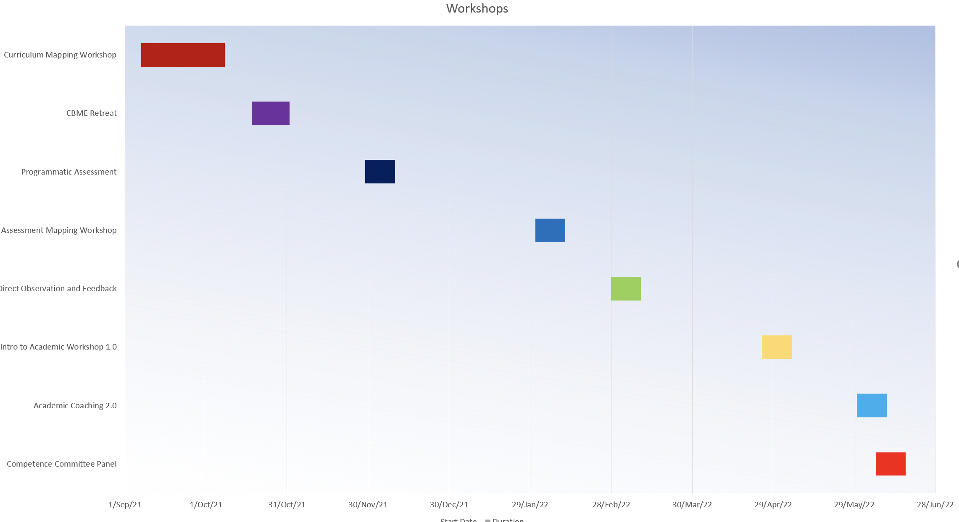
2021/22 Events + Gantt Chart

Workshops
Workshops will aim to address the needs of those who are approaching transition as well as those already transitioned.

Curriculum Mapping Workshop
Targeted Date: September 27th, 2021 / 8:30am to 11:30am

Accredited: No

Faculty Development Liaison:
Michelle Morais

Description:
Mapping the EPAs to the training experiences and how they will be assessed is a critical component of your rapidly approaching CBD transition. During this workshop, Drs. Lori Whitehead and Som Mukherjee will present different mapping templates and walk you through the process of developing your curriculum and assessment map. Guidance will be provided as to which template might work best for your program and you’ll have the opportunity for hands-on support as you consider your program’s map. There will be an introduction to assessment mapping and a follow up workshop to complete your assessment mapping.

Target Audience:
- Programs who are transitioning in July of 2022. The workshop welcomes all others who are interested to attend.

Direct Observation and Feedback
Projected Date: October 25th, 2021 / 1:30pm to 4:30pm
Accredited: Yes

Faculty Development Liaison:
Meera Luthra

Description:
Participants will be provided with the tools to help residency teachers improve their observation and feedback skills. Participants will understand the importance of direct observation and feedback as it relates to teaching, learning, and assessment in a competency-based education model.

Target Audience:
Program Directors, Academic Coaches, CBD Leads, Faculty, Resident Leads across ALL programs in CBD

Retreat
Projected Date: April 2022

Assessment Mapping Workshop
Projected Date: January 31 - Feb 11, 2021
Accreditation Submission Date: December 10th, 2022

Faculty Development Liaison:
Ilun Yang

Description:
This workshop is a follow-up to the Curriculum Mapping workshop that was held in September. If you weren’t able to join in September, we strongly encourage you to watch the recording of the session here. You can find the curriculum mapping templates that were presented here, under the 2020 accordion. Now that you have attended or watched the curriculum mapping session, you can map your EPAs to key learning experiences across your curriculum. We recommend starting with the Year at a Glance template, which we will revisit it during this workshop to align assessment methods and tools. More information will follow in the coming weeks regarding the recommended activities to complete before the workshop.

Target Audience:
- Programs approaching transition; Program Directors, Program Administrators, and CBD Leads.

EPA Assessment: The Conceptual and the Practical
Projected Date: February (TBD)
Accreditation Submission Date: December 2021

Faculty Development Liaison:
Mike Parrish

Description:
This workshop will engage discussion about entrustment, the assessment of the intrinsic CanMEDS roles, and how a program of assessment including EPA assessment, ITARs, and work-based assessment serves resident review and progression to competence in Competency by Design.

Target Audience:
PDs, CBD Leads, Cc Chairs, Resident Leads, Academic Coaches, program faculty development leads

Introduction to Academic Coaching Workshop 1.0
Projected Date: April 25-May 6, 2022
Accreditation Submission Date: February 28, 2022

Faculty Development Liaison:
Anne Wong

Description:
This event will provide participants with an overview of the role of the academic coach, case studies, etc., that they will be able to use and adapt for use in their own program.

Target Audience: Program Directors, Academic Coaches

Academic Coaching 2.0: Beyond the Basics
Projected Date: May 30th- June 10th 2022
Accreditation Submission Date: April 4, 2022

Faculty Development Liaison:
Ereny Bassilious

Description:
In CBD, Coaching over Time describes an important relationship between an Academic Coach and a learner. The coach guides the learner as they progress through the CBD stages of training. In this workshop, participants will have the opportunity to build on basic foundations of Academic Coaching principles and further explore this coaching relationship and how to support learners across the various stages of their learning journey. Using the framework of motivational interviewing, participants will practice coaching skills in more challenging situations.

Target Audience: Program Directors, Academic Coaches

CBME Competence Committee Discussion Forum: Conundrums, Clarifications, Considerations
Projected Date: June 6-17, 2022
Accreditation Submission Date: May 11, 2022

Faculty Development Liaison:
TBD

Description:
This discussion forum will guide participants through the processes of identifying the requirements of a Competence Committee across structure, function, and process. Participants will also be introduced to a new Competence Committee Checklist and strategies to ensure an efficient deliberation process. Through consideration of the roles of the the Program Administrator, Academic Coach, residents, and (external/internal) members of a Competence Committee, participants will be able to conduct comprehensive review/progression decision-making for all residents

Target Audience:
- Program Directors, CBD Leads, Program Administrators, CG Chairs

Competence Committee, Case Based Discussion
Projected Date: CBME retreat Oct. Nov 2022. Include with Parveen's and Direct Obs workshop with EB and ML
Accreditation Submission Date: August 2022

Faculty Development Liaison:
TBD

Description:
This event will provide participants with an overview on competence committees and understand how competence committees make decisions on resident progression. Participants will be provided with case studies that they will be able to work through and use with their own programs.

Target Audience:
- Program Directors, Academic Coaches, CBD Leads, Resident Leads

