PA Tips & Tricks for MedSIS Dashboard Use
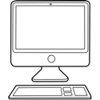
Setting up the Dashboard – see links provided by MedSIS https://healthsci.mcmaster.ca/medsis/training/cbme

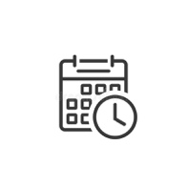
Notify trainees, PD, Competency Committee and Academic Coaches of Competency Committee Meeting dates for the entire year.

Send trainees, PD, Competency Committee and Academic Coaches reminders (2-3 weeks prior to Comp. Comm. meeting) for Trainees and Academic Coaches to meet, review, edit, and upload required information to the Dashboard
Have your Trainees and Academic Coaches to upload their required documents to the Dashboard. You can still review the Dashboard prior to the meeting to ensure all documents are in place in time for the meeting.

I have created a Google Doc for the Academic Coaches and Competency Committee to upload/review documents prior to the meeting. The folder includes each trainee’s requirements that are reviewed (for CCM – Personal Learning Plan, Academic Week Accountability Form, Night Call Evaluation, Academic Coach Review, Secondary Coach Review, Competency Committee Letters). While it seems like a duplication of work, this folder keeps all trainees in one place for Comp. Comm. easy viewing during the meeting and acts as a backup in case there are any glitches with MedSIS (you literally just need to drag the files over).
The Critical Care Medicine Dashboard has been set up to allow the Comp. Comm. Chair, PD, Academic Coaches update the “EPA completions” & “progressing” so we can change trainee status as we go through the meeting.

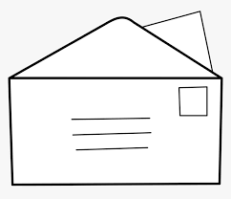
Both the Competency Committee Chair and I take notes during the meeting, letters are drafted, returned to Competency Committee Chair for signature and then uploaded to Google Docs for Residency Program Committee to review prior to the RPC meeting in order to just keep trainee updates to an FYI during the meeting. We have a standard letter for each stage and progression, and note in the letter the trainee’s strengths, weaknesses and contact information of Program Director and Competency Committee Chair for any further clarification, assistance, guidance etc. pertaining to EPA completion.
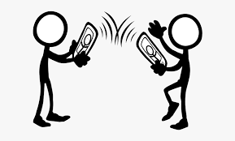
Trainees who are not progressing as expected are notified in advance of receiving their letter by their Academic Coach. The status on the Dashboard is not updated until after this conversation either.

The MedSIS Review Dashboard is a great tool that can be easily, viewed and updated prior to, during and post meetings for the Competency Committee and the Trainee.

