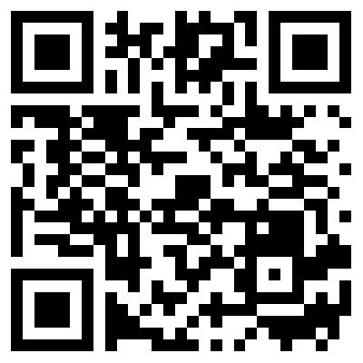CBME
Newsflash!
MedSIS is now Mobile Friendly!

Scan the QR code or visit the link below for Quicker
Easier
completion of EPA assessments!

h ttps://medsis.mcmaster.ca/mobile/#authenticate

T I M E L Y A S S E S S M E N T S W I L L
B E M O R E A C C U R A T E & U S E F U L
Thank you for completing assessments before they expire!

