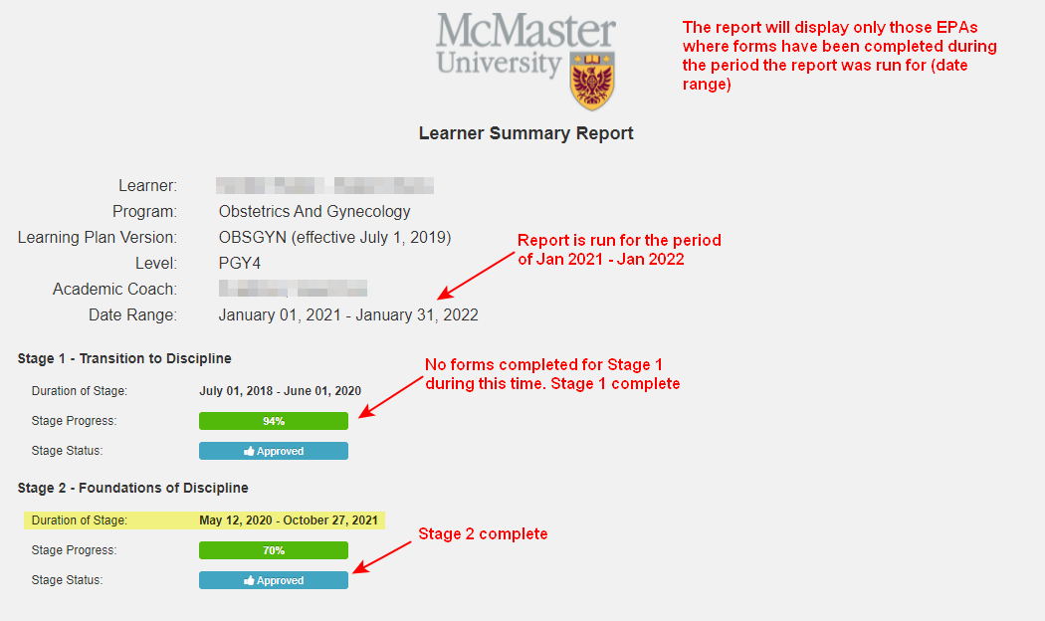
NOTE: stage status can be manually signed off on by committee/RPC at any point. Progress percentages will not change (ie: programs that accept 4s/5s)
EPA Summary:
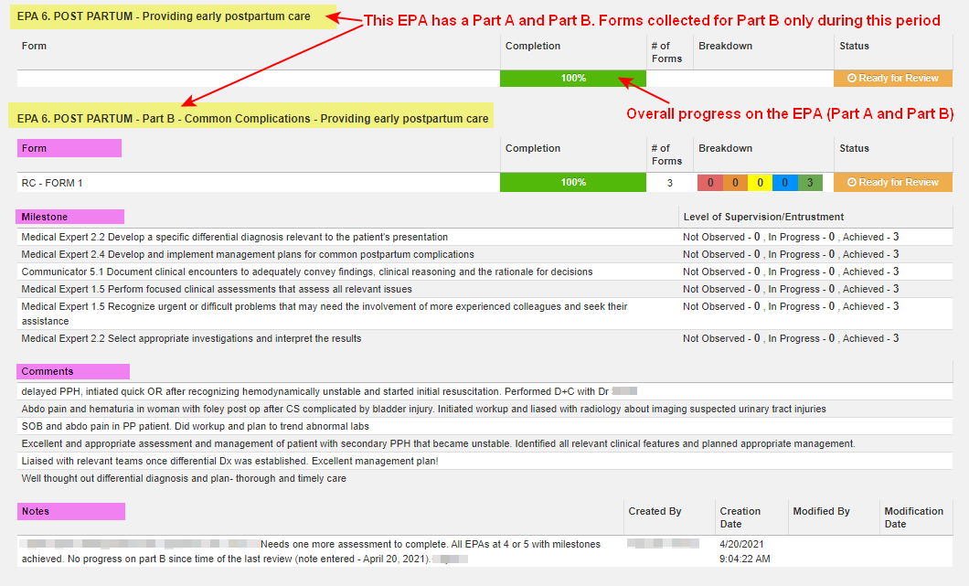
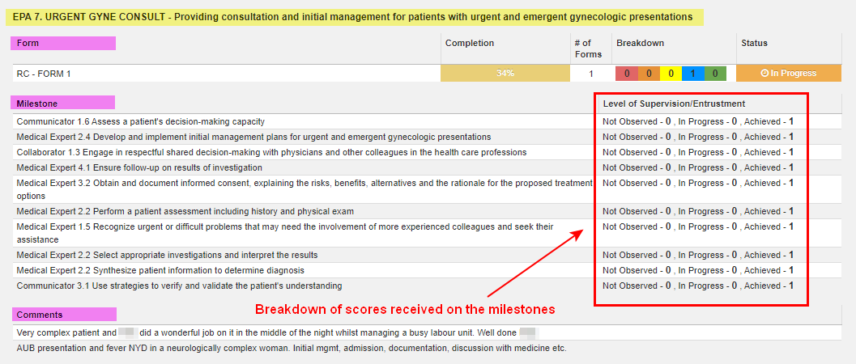
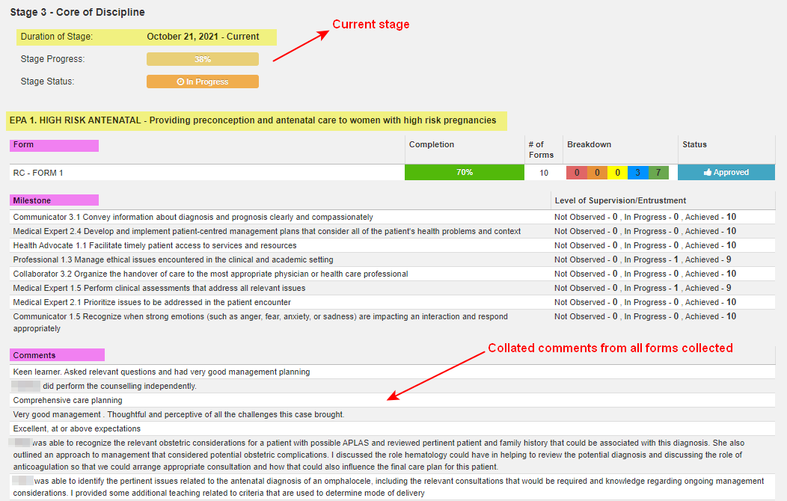
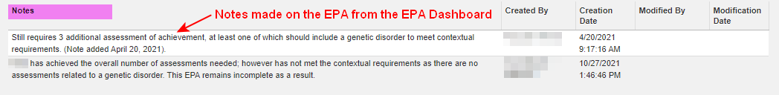
Where notes are made on the EPA dashboard:
ITER Summary:
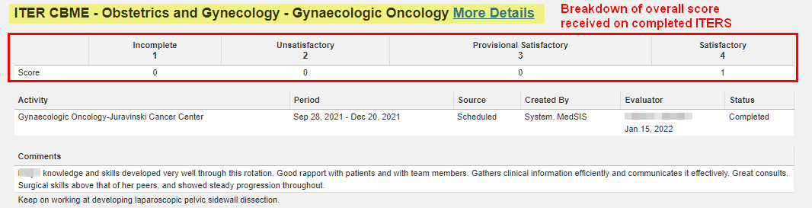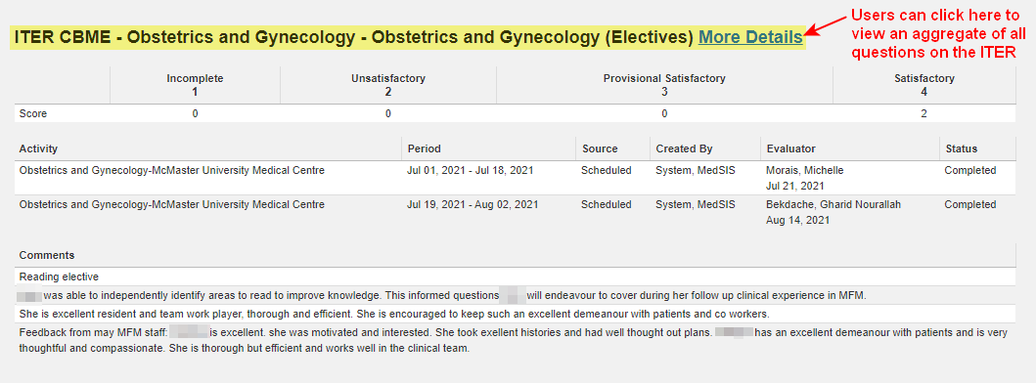
Example of an ITER report when users click ‘More Details’ (only available when viewing the report in MedSIS, not when viewing a PDF version of the report)
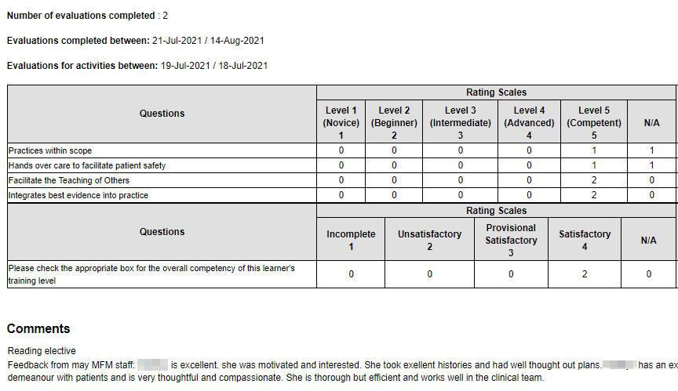
Procedure Log Summary:
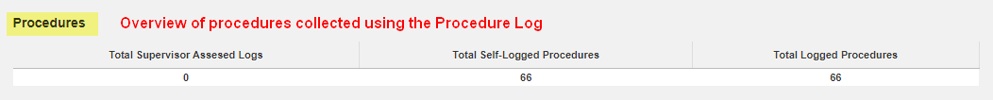
Event Attendance Summary:

